training 1 epoch...

99.6545021533966 seconds used......

1 training finished! average train loss: 0.67501113258657

evaluating...

Confusion matrix, without normalization

[[ 5 18 30]

[ 4 144 33]

[ 0 18 215]]

Normalized confusion matrix

[[0.09433962 0.33962264 0.56603774]

[0.02209945 0.79558011 0.18232044]

[0. 0.07725322 0.92274678]]

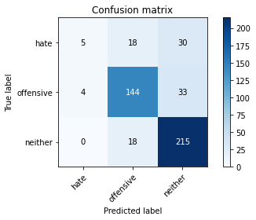

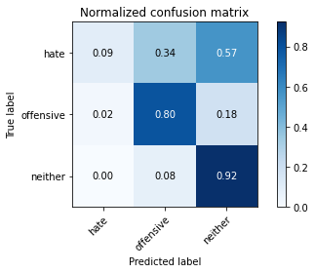

precision recall f1-score support

hate 0.56 0.09 0.16 53

offensive 0.80 0.80 0.80 181

neither 0.77 0.92 0.84 233

accuracy 0.78 467

macro avg 0.71 0.60 0.60 467

weighted avg 0.76 0.78 0.75 467

average eval_loss: 0.5441071024785439, accuracy: 0.7794432548179872

training 2 epoch...

106.9554991722107 seconds used......

2 training finished! average train loss: 0.4663331327693803

evaluating...

Confusion matrix, without normalization

[[ 20 16 17]

[ 23 141 17]

[ 21 25 187]]

Normalized confusion matrix

[[0.37735849 0.30188679 0.32075472]

[0.12707182 0.77900552 0.09392265]

[0.09012876 0.10729614 0.80257511]]

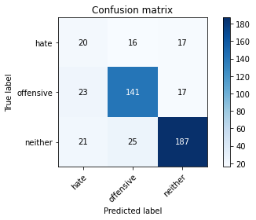

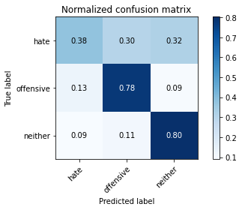

precision recall f1-score support

hate 0.31 0.38 0.34 53

offensive 0.77 0.78 0.78 181

neither 0.85 0.80 0.82 233

accuracy 0.75 467

macro avg 0.64 0.65 0.65 467

weighted avg 0.76 0.75 0.75 467

average eval_loss: 0.5901012706259886, accuracy: 0.7451820128479657

training 3 epoch...

106.55049872398376 seconds used......

3 training finished! average train loss: 0.30738340616226195

evaluating...

Confusion matrix, without normalization

[[ 15 17 21]

[ 21 142 18]

[ 13 26 194]]

Normalized confusion matrix

[[0.28301887 0.32075472 0.39622642]

[0.1160221 0.78453039 0.09944751]

[0.05579399 0.11158798 0.83261803]]

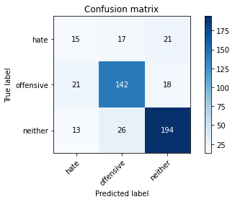

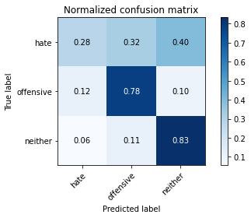

precision recall f1-score support

hate 0.31 0.28 0.29 53

offensive 0.77 0.78 0.78 181

neither 0.83 0.83 0.83 233

accuracy 0.75 467

macro avg 0.64 0.63 0.63 467

weighted avg 0.75 0.75 0.75 467

average eval_loss: 0.6877021193504333, accuracy: 0.7516059957173448

training 4 epoch...

106.62604308128357 seconds used......

4 training finished! average train loss: 0.16123922632208892

evaluating...

Confusion matrix, without normalization

[[ 21 13 19]

[ 27 136 18]

[ 17 19 197]]

Normalized confusion matrix

[[0.39622642 0.24528302 0.35849057]

[0.14917127 0.75138122 0.09944751]

[0.07296137 0.08154506 0.84549356]]

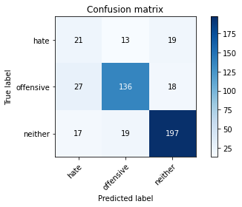

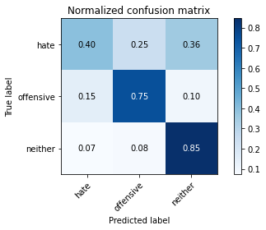

precision recall f1-score support

hate 0.32 0.40 0.36 53

offensive 0.81 0.75 0.78 181

neither 0.84 0.85 0.84 233

accuracy 0.76 467

macro avg 0.66 0.66 0.66 467

weighted avg 0.77 0.76 0.76 467

average eval_loss: 0.7904124688357115, accuracy: 0.7580299785867237

training 5 epoch...

106.5513072013855 seconds used......

5 training finished! average train loss: 0.05958090127401409

evaluating...

Confusion matrix, without normalization

[[ 11 19 23]

[ 20 141 20]

[ 9 24 200]]

Normalized confusion matrix

[[0.20754717 0.35849057 0.43396226]

[0.11049724 0.77900552 0.11049724]

[0.03862661 0.10300429 0.8583691 ]]

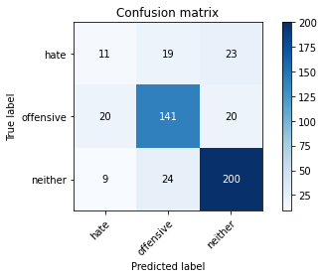

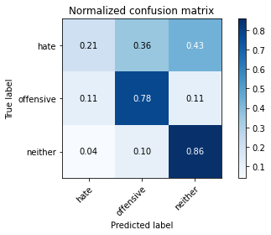

precision recall f1-score support

hate 0.28 0.21 0.24 53

offensive 0.77 0.78 0.77 181

neither 0.82 0.86 0.84 233

accuracy 0.75 467

macro avg 0.62 0.61 0.62 467

weighted avg 0.74 0.75 0.75 467

average eval_loss: 1.0667180540040135, accuracy: 0.7537473233404711

model of 4 epoch

Confusion matrix, without normalization

[[ 85 62 43]

[ 76 299 40]

[111 58 544]]

Normalized confusion matrix

[[0.44736842 0.32631579 0.22631579]

[0.18313253 0.72048193 0.09638554]

[0.15568022 0.08134642 0.76297335]]

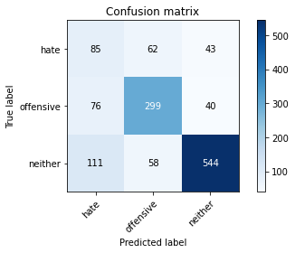

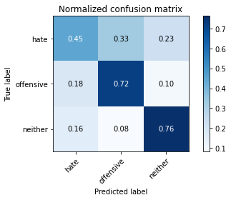

precision recall f1-score support

hate 0.31 0.45 0.37 190

offensive 0.71 0.72 0.72 415

neither 0.87 0.76 0.81 713

accuracy 0.70 1318

macro avg 0.63 0.64 0.63 1318

weighted avg 0.74 0.70 0.72 1318

average eval_loss: 0.8882112579815316, accuracy: 0.7040971168437026

0.7040971168437026